August 9, 2016

The Honorable Paul Tonko The Honorable Steve Stivers
United State House of Representatives United State House of Representatives
Washington, DC 20515 Washington, DC 20515

The Honorable Jim Langevin The Honorable Gregg Harper
United State House of Representatives United State House of Representatives
Washington, DC 20515 Washington, DC 20515

Dear Representatives Tonko, Stivers, Langevin and Harper:

On behalf Easterseals, I am writing to express our support for the Disability Community Act of 2016 (H.R. 5902).

Easterseals is changing the way the world defines and views disabilities by making profound, positive differences in people’s lives every day. Through a network of community-based affiliates, Easterseals assists people with disabilities in reaching their potential by providing home and community-based services (HCBS) and other services funded by Medicaid. Easterseals values our highly skilled workforce and recruits the highest quality employees to deliver our services and implement our programs. We do this through competitive wages and benefits, rewarding work, and a positive and flexible work environment.

However, the fiscal reality of state Medicaid reimbursement is grim. Current reimbursement rates fail to meet the full costs of program services and several states are considering further cuts to critical Medicaid services. The three years of increased federal Medicaid funding provided by the Disability Community Act will help states work with Easterseals and other stakeholders to adjust reimbursement rates and service models to assure vital services remain available to people with disabilities. Your bill will help states work with Easterseals and other service providers to meet the increased costs of compliance with new labor rules.

Thank you for your leadership on this issue. We look forward to working with you as this legislation advances to assure that people with disabilities have access to the supports they need to live, learn, work and play in their communities.

Sincerely,
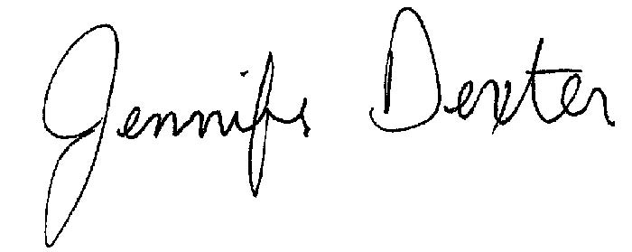
Jennifer Dexter
Assistant Vice President, Government Relations

