Nominee Name
Nominee Address 1
Nominee Address 2
Nominee City, State ZIP Code

May 11, 2023

Dear First Name,

You may not have been aware, but one of your colleagues nominated you for one of ANCOR’s 2023 Direct Support Professional of the Year awards. Although we regret to inform you that you were not selected for an award, we were impressed by your achievements and would be remiss if we didn’t take a moment to congratulate you for your accomplishments and thank you for your contributions to our community.

This year, we had an incredible pool of over 350 nominees for these annual awards. It is our privilege to recognize professionals like you who are working tirelessly to empower and support individuals with developmental disabilities. Every year, the committee of judges embarks on the humbling task of evaluating a competitive application pool, and every year the committee is overjoyed by the triumphs and sacrifices of the nation’s direct support professionals.

Although you may not recognize it, the work you do is essential to ensuring that people of all abilities can live, work and thrive in the community. To say that we have immense appreciation for your contributions would be a tremendous understatement.

As a small token of our appreciation for your work as a direct support professional, please accept this Certificate of Recognition. This symbol recognizes you and the important work your nominator shared with us, so we hope you will display it proudly in your home or workplace!

On behalf of the entire ANCOR community, we owe you a debt of gratitude, and offer our sincerest thanks for exemplifying excellence in direct support. Our community and our country are stronger because of you!

Sincerely,
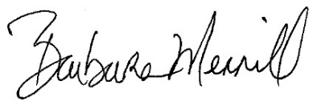
Barbara Merrill
Chief Executive Officer
ANCOR

