Certificate of Recognition

This is to certify that:

FirstName LastName

Is Hereby Awarded Honorable Mention in the
ANCOR 2023 Direct Support Professional Award Program
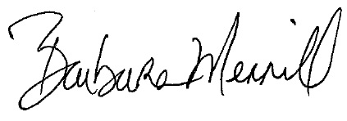
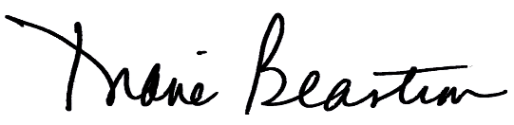
Diane Beastrom, President Barbara Merrill, CEO

