Certificate of Recognition

This is to certify that:

FirstName LastName

is hereby awarded honorable mention in ANCOR’s
2024 Direct Support Professional of the Year recognition program

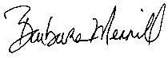
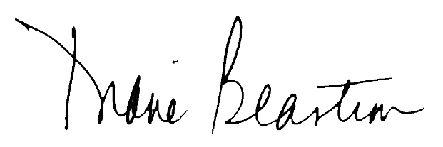

Diane Beastrom, President Barbara Merrill, CEO

