[DSP Name]
[DSP Organization]
[DSP Address 1]
[DSP Address 2]
[City], [State] [ZIP Code]

[Date]

Dear [DSP First Name],

Each year, ANCOR solicits nominations for our annual Direct Support Professional of the Year Awards. This year, you were among the incredible pool of nearly 500 candidates to be nominated for a 2024 DSP of the Year Award.

It is our privilege to recognize those working tirelessly to empower and support individuals with developmental disabilities. Every year, our committee of judges embarks on the humbling task of evaluating a competitive application pool, and every year the committee is overjoyed by the triumphs and sacrifices of the nation’s direct support professionals.

Although you weren’t selected for an award this year, we are committed to demonstrating our immense appreciation for the work that they do every day. We know the daily challenges of your work, and how they have been exacerbated by the myriad challenges of the past two years.

We know that without you, people with disabilities would have less independence, less access to their community, and fewer opportunities to live a fulfilling life. We owe you a debt of gratitude for the work you do to support your community.

Sincerely,
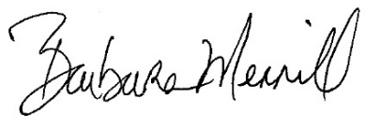
Barbara Merrill, Esq.
Chief Executive Officer
ANCOR

