

***Certificate of Recognition***

*This is to certify that:*

*FirstName LastName*

*is hereby awarded honorable mention in ANCOR’s*

*2025 Direct Support Professional of the Year recognition program*

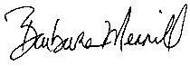

*Lori Kress, President Barbara Merrill, CEO*