Certificate of Recognition

This is to certify that:

FirstName LastName

is hereby awarded honorable mention in ANCOR’s
2026 Direct Support Professional of the Year recognition program

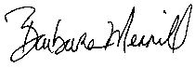
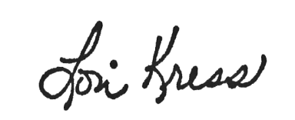

Lori Kress, President Barbara Merrill, CEO

